//Anthony Zovich

//Programming Languages 355

//09/06/15

// Threads Programing

//Description: Re-write the Monte Carlo program with threads and then compare the time difference

CODE:

#include <pthread.h>

#include <stdio.h>

#include <stdlib.h>

#include <time.h>

#include <stdint.h>

#include <math.h>

#define NUM_THREADS 8

#define NITER 10000055

#define SEED 32754545

void *calc_pi(void *thread_id)

{

double x;

double y;

double result;

double pi;

long thread =(long)thread_id;

int t_id = (int)(intptr_t)thread;

float *count = (float *)malloc(sizeof(float));

*count=0;

double total= NITER/NUM_THREADS;

srand(SEED);

for(int i=0;i<total; i++){

x=(double) rand()/RAND_MAX;

y=(double) rand()/RAND_MAX;

result = sqrt((x*x) + (y*y));

if(result<=1){

*count+=1;

}

}

if(t_id==0){

double remainder = NITER%NUM_THREADS;

for(int i=0; i<remainder; i++){

double x = (double) rand()/RAND_MAX;

double y = (double) rand()/RAND_MAX;

double result = sqrt((x*x) + (y*y));

if(result<=1){

*count+=1; //check if the generated value is inside a unit circle

}

}

}

pthread_exit((void *)count); //return the in count

}

int main(int argc, char *argv[])

{

pthread_t threads[NUM_THREADS];

int go;

void *status;

float total=0;

clock_t start=clock(), diff;

for(int i=0; i<NUM_THREADS; i++){

go = pthread_create(&threads[i], NULL, calc_pi, (void *)(intptr_t)i);

if (go){

printf("ERROR");

exit(-1);

}

}

//join the threads

for(int i=0; i<NUM_THREADS;i++){

pthread_join(threads[i], &status);

//printf("Return from thread %ld is : %f\n",t, *(float*)status);

total+=*(float*)status; //keep track of the total in count

}

diff= clock()- start;

int time= diff*1000 /CLOCKS_PER_SEC;

printf("Value for Pi is %f \n",1, 4*(total/NITER));

printf("Time with threads is %d clock cycles \n", time/1000);

pthread_exit(NULL);

}

//OUTPUT:

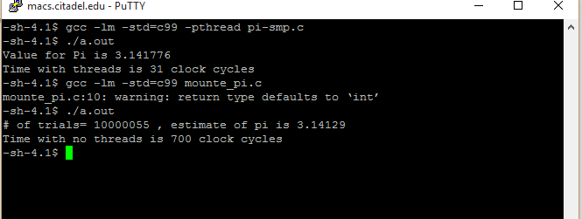

//Conclusion: Programs with threads run faster than programs that do not have threads in them.